Shabbos Stories for
Parshas Chaya sarah 5781
Volume 12, Issue 10 27 Cheshvan/November 14, 2020
Printed L’illuy nishmas Nechama bas R’ Noach, a”h

For a free subscription, please forward your request to keren18@juno.com
Past stories can be found on the website ShabbosStories.com
Lessons from the Man
Who Honored Shabbat
By Rabbi David Sutton

The Gemara in Masechet Shabbat tells the story of a man named Yosef Mokir Shabbat – “Yosef Who Honors Shabbat.” He was well-known for spending considerable amounts of time and money for the sake of honoring Shabbat.
During his time, there a lived a certain wealthy, non-Jewish man who had a dream that his entire fortune would end up belonging to Yosef Mokir Shabbat. In order to prevent this from happening, the man went ahead and sold all his possessions. He took the money and purchased a very expensive jewel which he kept with him at all times, thereby ensuring that it would never end up in the hands of Yosef Mokir Shabbat.
As an added measure of protection, he placed the jewel in his turban and wrapped the turban tightly around his head. One day, the man was walking on a bridge over a river when a gust of wind came and blew his turban off his head into the river. The jewel in the water ended up being swallowed by a large fish, which was then caught by a fisherman.
The fisherman brought the fish to the market on Erev Shabbat, and asked around to find out if there was anyone who would spend money to purchase such a large, special fish. He was told to offer the fish to Yosef Mokir Shabbat, who didn’t spare any expense when it came to honoring Shabbat.

Bought the Fish, Opened it Up and Found the Jewel
Sure enough, Yosef bought the fish, opened it up, found the jewel, and thereby acquired all the other man’s wealth. The man heard about what happened and was so distressed that he took his own life.
This story teaches us the importance of honoring Shabbat, and how we will be rewarded for all the extra effort and expense we invest in order to give Shabbat the respect it deserves.
The Ben Ish Hai adds that there is also another lesson to be learned from this story, namely, that working to oppose Hashem’s plan will always backfire. Not only will such efforts fail, but they will actually contribute to the materialization of Hashem’s plan.
The man thought he could “outsmart” G-d’s decree by selling his assets and keeping a jewel in his turban. In the end, it was precisely as a result of these measures that Hashem’s plan materialized, and Yosef Mokir Shabbat received all his wealth.

Reprinted from the Parshas Lech Lecha 5781 edition of iTorah.com

We Are Never Alone
By Rabbi David Ashear

If someone feels lonely or feels that he doesn’t have anyone to look after him, he must internalize that he has the King of the world with him at all times, and He is looking after him better than anyone else possibly could. It should be so comforting to know that we are never alone, and we always have Hashem taking care of us. He is our provider, He gives us help, and He is always acting with us in a way that is most beneficial to us.
A woman who organizes meals for people in need, especially single parents, told me that before Sukkot she had ten families who contacted her for meals, and she sent the meals out with a messenger to deliver them. When the messenger returned, he told her “there were ten boxes of food, but there were eleven people on the list you gave me. So the last person didn’t get one.”
She looked at the paper and realized it was a list from a previous delivery. It was mostly the same people, just one of them didn’t order this time, and they got the meal that was supposed to go to the last person. So she called up that first family and said, “By accident we sent you a box of food. Could I send someone to pick it up?”
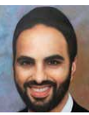
Rabbi David Ashear

That family told her, “We were so excited when the box came, because we didn’t have any food for Yom Tov.”
The woman said, “Okay, baruch Hashem, I’m so happy that you have food.” She then called that last family which consisted of little children and a single mother. She told the mother, “I’m so sorry your food wasn’t delivered yet, but I’m going to the store right now to pick up some things for you.”
The single mother told her, “Oh, I’m glad you are telling me because my children have a very restricted diet and only eat certain things.” And she proceeded to tell her what those foods were. Then she said, “I haven’t been feeling well. I tested positive for Covid, and I’m having trouble breathing. I’m so scared. I don’t know what to do.”
This woman quickly sprang into action. She called Hatzalah and met them there. They were able to get this woman a breathing apparatus that potentially helped save her life. And later that day, this woman got the exact food that her family eats delivered to her door.

The Wrong Paper Helped a Poor Family
Hashem made sure that everyone who was in need here was helped. By the woman using the wrong paper that was Hashem’s way of giving that other family meals for the holiday and that was His way of making sure that this woman got the help that she needed.
There was also another family who called the woman to thank her for delivering the meals. They asked her, “Is there any possibility of us getting meat instead of chicken?”
She apologized and said that is all she had available. Less than five seconds later, her phone rang with the person on the other line saying she had cooked three extra full meat meals and asked if she knew of anyone in need. The woman called that other family right back and said, “Hashem arranged for you to have meat this holiday.” And she delivered those meals.
Another woman emailed me. She has a neighbor who is 99 years old and lives alone. A few weeks ago, he called them asking if they could take him to shul to say Kaddish on his wife’s yahrtzeit that coming Thursday. They told him, “It is too dangerous for you to be in public. We’ll bring a minyan to your house on Thursday, and we’ll pray outside.”

Checking with the Old Man on Thursday
That Thursday they called his home to see what time he wanted to pray, but there was no answer. They tried a few more times but there was still no answer. About 45 minutes before the time they figured to start, they went to his home and knocked on the door. They heard a faint voice from a distance calling for help. They immediately called the Fire Department and Hatzalah who came and broke the door down. The man had fallen and was badly bruised. He was too weak to get up and the emergency call button on his neck did not work. Who knows how long he could have been there until anybody discovered him? Hashem ensured that this man, who was all alone on the floor, would be taken care of properly. We are never alone, and we are always being cared for.

Reprinted from the Parshat Lech Lecha 5718 website of iTorah.com

The Lost Wallet and My Return to the Jewish People
By Sofya Sara Esther Tamarkin

Years ago, a few friends and I headed to New York City for a day of bonding and recreation. We drove to the station, parked, hopped on a train to the city, and spent an enjoyable day visiting museums and taking in the sights. Since we bought all the tickets in advance, I had no need to take out my wallet during the trip. But when I stepped off the train at the end of the day on our way home, I suddenly realized it was missing.
I was pretty sure I had dropped it on the train, but when I ran back to check, it was not under my seat as I had expected. My friends tried to offer words of encouragement, but I just wanted to be alone.
I was walking a few steps behind them, overwhelmed by thoughts of all the work I would have to do to replace my credit cards, driver’s license, car insurance, IDs and pictures. I didn’t notice we were walking around the parking garage in circles in our effort to find our car. Apparently, in our excitement that morning we hadn’t paid much attention to our parking spot.
While going up the steps for the third time, I heard someone call my name. I looked up in surprise and saw an older couple standing on the staircase in front of me. The woman was holding up my driver’s license, looking intently at the picture and then at me. She was holding my wallet in her other hand, clearly trying to identify if I was indeed the rightful owner.
I could barely speak. After a few seconds, the couple explained: When I first got out of the car this morning, my wallet must have fallen and slipped under their car, which was parked next to ours, and stayed hidden from view for the entire day.
They had arrived back on a train just a few minutes after us. While pulling out of their parking space, they caught a glimpse of the wallet. Incredibly, they reparked and decided to walk around the lot looking for the owner.

The Unusual Chances of Finding Me
What were the chances of finding me after a 12-hour day at the parking garage? The only reason we bumped into each other was because my friends couldn’t find our car! If that hadn’t been the case, we would have left 15 minutes before their arrival.
I tried to regain my composure, offering financial compensation to show gratitude for their integrity and kindness. Unsurprisingly, the couple refused. They insisted that it was G-d’s Providence, what we would call hashgacha pratit. I offered to make a donation on their behalf, and they agreed for me to donate to a cancer-research fund.
Many years later, I wish I could tell these wonderful people that their simple act of kindness infused me with clarity to find my own unique place in the world. It created a visual reminder for me that the return of a lost item is possible despite its very unlikely circumstances. If the Creator of the world orchestrated all this, then I knew that I, too, could be assured that I would not be lost forever.
Since my family’s immigration to the United States in 1989, I have been actively trying to find my place among the Jewish people.

A 13-Year-Old’s Visit to the Lubavitcher Rebbe
When I was 13 years old, Rabbi Avraham Shemtov organized a trip from Philadelphia for the newly arrived immigrants to meet the Lubavitcher Rebbe. I will never forget the moment I stood before the Rebbe, a lost Soviet child, meeting his gaze and discovering my own internal compass. In his eyes, I saw a reflection of a map that eventually guided me back to my Jewish heritage.
It took many years of detours until I found my destination. Perhaps detours and unexpected turns are all part of the intricate plan that eventually leads us towards the right destination.
It takes courage and clarity to know that the circumstances that prevent us from moving forward are not simple roadblocks, but signs placed in front of us by the Divine Providence.
While the medieval proverb proclaims that “All roads lead to Rome,” I have learned firsthand that all roads lead us back to oneness, to the part of infinite “self” that is forever connected to the Creator.

Reprinted from the Parshas Vayeira 5781 email of Chabad.Org Magazine.
Stories Highlighting the Importance of Hachnasis Orchim (Hospitality)

Once, Rebbe Moshe Kobriner was a guest in the home of Rebbe Aharon Karliner zt'l. Reb Aharon told him that his daughter was ill. Rebbe Moshe Kobriner said to the ill girl, "Your father is performing hachnasas orchim (hospitality). This means right now, he has the stone of healing hanging on his neck. Look at your father, and you will be healed."

The Sar Shalom of Belz zt'l built a majestic shul in Belz. Two generations later, his grandson, Rebbe Yissachar Dov of Belz. zt'l, added the Groiyse Shtub, a large room where the tishen were celebrated.

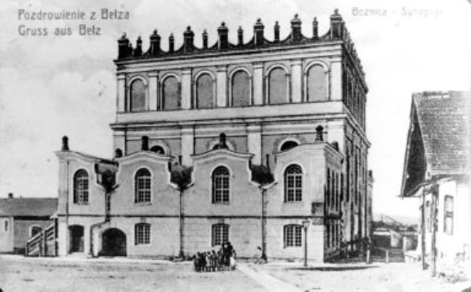

When the construction of the Groiyse Shtub was completed, Rebbe Yissachar Dov said, "A thousand years ago, on this spot, there lived a Yid (Jew) who excelled in the mitzvah of hachnasas orchim – like Avraham Avinu. When my grandfather built the shul, this Yid thought it was time for techiyas hameisim (the Resurrection of the dead).
He got out of his grave and came to my grandfather. The Sar Shalom told him that it isn't techiyas hameisim [time] yet, and the niftar returned to his grave. In the merit of his hachnasas orchim, which he kept with all his might right here, the Groiyse Shtub was built on that spot."

The House of the Holy Rebbe Yechezkel Kozmir
At night, the city Kozmir was silent and all homes dark. But one house was lit up. It was the house where Rebbe Yechezkel Kozmir zt'l lived, for he would wake up at midnight and study Torah until the morning. Two travelers once arrived at the city in the middle of the night and needed a place to stay. They knocked at the Rebbe's home, the only house that was lit.
The Rebbe took them in, prepared a meal for them, and a place to sleep. This caused some noise, which awoke the gabbai, who slept in the next room. The gabbai thought, "Who could come to the Rebbe's house so late at night? I must be hearing neshamos (elevated neshamos).
The gabbai assumed that neshamos came to the rebbe so he can rectify their souls! The gabbai was afraid to see neshamos, so he stayed in his room. The next morning, at shacharis, the gabbai told people about the neshamos who visited the rebbe's home the previous night.
The rebbe said, "It's true that two neshamos came to me last night, but they didn't come to me so I can fix their neshamos. They came to fix my neshamah," because, through the people that came to Rebbe Moshe Kobriner's home, he had the merit to perform this special mitzvah [of offering hospitality to another Jew].

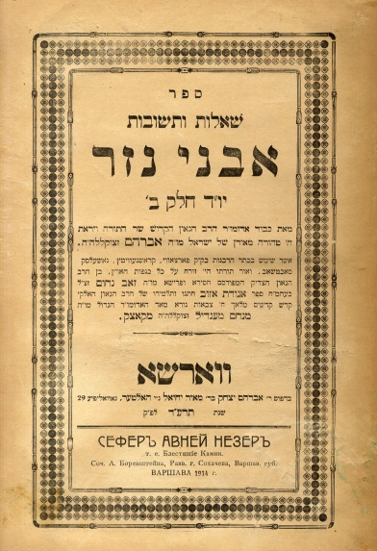

The Avnei Nezer zt'l was once serving a guest who protested, "I'm a simple person. I don’t deserve this honor." The Avnei Nezer opened the window. There was a tannery across the street. The Avnei Nezer said, "In the tannery, you find hides. But when these hides becomes tefillin, they become holy.
“Similarly, regardless of your level, now you are a mitzvah, a cheftza shel mitzvah (an item used for a mitzvah) so now you are kadosh.

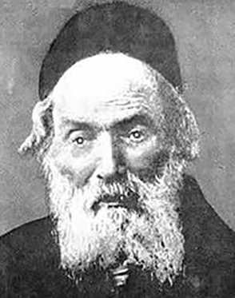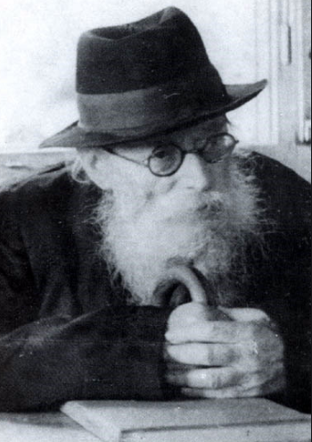
The Chofetz Chaim, zt”l The Chazon Ish, zt”l

The Chofetz Chaim zt'l was taking care of a guest. The guest said, "You don’t have to do this for me. Really, I can set up the room myself…"
"Really?" the Chofetz Chaim replied. "And tomorrow, will you wear my tefillin for me?"
As a bachur, Reb Chaim Brim zt'l would often travel to Bnei Brak to speak in learning with the Chazon Ish zt'l, and then he would return to Yerushalayim, where he lived. One night, he missed the last bus back, so he had to stay the night in Bnei Brak in the Chazon Ish's home. He tells that he felt very uncomfortable, because three great people served him. The Chazon Ish, (the Chazon Ish's brother-in-law) the Steipler, and the Steipler's rebbetzin. The Chazon Ish gave the orders; one brought negel vasser, one brought food, another prepared a bed…
He said, "Please don’t do this for me."
The Chazon Ish replied, "Since when does an esrog tell the person holding him how he should be handled? Now you are a mitzvah, and you can't tell the people who are obligated to do this mitzvah how to perform it."

Reprinted from the Parshas Lech Lecha 5781 email of Torah Wellsprings: Collected Thoughts from Rabbi Eli Biderman.

The Informer Who Called the Police on the Chasanah During the Covid Pandemic

Last week Rav Elimelech Bidermen publicized the following story:
During the Covid pandemic a chassan (bridegroom) and kallah (bride) were to get married in an Israeli yeshiva. Shortly after the chupah (wedding ceremony), the police arrived, shut down the hall, and took the chosson, kallah, and the kallah's father in to the station until three o'clock in the morning!
Their long awaited chasunah (wedding) day turned in to one big disappointment. Fast forward a few months, and the father of the kallah received a phone call.
It was a bochur from the yeshiva were his daughter got married. The boy began to tell him how he was the one who called the police, for he was reading up about the dangers of the virus, and he was nervous that people were getting too close to each other. He had no idea they would shut down the entire wedding, he thought they would just enforce the rules.
Either way, since the day he called the police, his parent's hadn't received even one shidduch phone call (from a matchmaker), and he knew the reason why. Therefore, he was calling to beg for (mechila) forgiveness from the kallah's father.
The kallah's father told the boy that he ruined the entire wedding and it would be very hard for him to forgive him. The boy began to cry and beg, and the father told him to call back the next day. He called the next day and the father told him that he had found it in his heart to be mochel him, yet he still had two more phone calls to make; one to the chosson and one to the kallah.
So the bochur called the chosson, and told him that he was the one who called the police…. And he began to beg for mechilah. After lots of tears from the boy, the chosson was mochel.
Yet, when he called the kallah, she couldn't find it in her heart to be mochel the one who ruined her long awaited wedding day. It was still haunting her. The bochur begged and cried, but to no avail.
The bochur then got a Rov to call the kallah and the Rov explained to her the greatness of mechilah, and the fact that one can never know what it will spare them from. With great encouragement, the kallah was mochel the bochur.

A few weeks after this story, the new couple were in a terrible car accident. The medics who arrived on the scene didn't expect that anyone survived. Yet, to their shock, they saw the young couple healthy and fine on the side of the road! They had crawled out of the car window without any harm! Hashem gave this couple the zchus (merit) of being moichel and ultimately they became the receivers of the best bracha (blessing) Shayach in this world – the bracha of חיים (life).

Reprinted from the Parshas Vayeira 5781 email of Eitz Hachayim.

Overcoming One’s Bitter Feelings For One Who Harmed Him

HARAV YITZCHOK ZILBERSTEIN RELATED the following story. There was a person who did something terrible to a talmid chacham (Torah scholar) .A few days later, this person sent a letter to ask for forgiveness. This talmid chacham, who was still terribly distressed by what the man did, was having a difficult time trying to overcome the pain and forgive this person - to the point that he wanted to just tear up the letter.
His wife, however, asked him please not to tear the letter, and she gave him an eitza (advice) . She suggested that he should take the letter and place it between the pages of his siddur (prayer book), and when he is standing in middle of Shemonah Esrai (Silend Amida) ,in front of the blessing that Hashem should forgive us for our sins, the talmid chacham should stop for a moment, take out the note, and say in his heart - “Ribbono shel Olam, Master of the world) ,You see how hard it is for me to forgive this person for what he did to me. However, despite all this I am overcoming my tendencies in order to forgive this person who humiliated me. Please forgive me too on all my sins…”

Reprinted from the Parshas Vayeira 5781 email of Eitz Hachayim.

The Fruit of Faith

After years of working in an office, my wife and I asked our Rav for advice. He suggested that I find a job where I can work from home since parnasah comes from Above and is only based on the effort one exerts. So what difference is there if the effort is exerted at home or outside?
Following the decision, my wife took a course in fruit platter arrangement since this was close to her heart, especially since we are a family that hosts a lot and she always arranges fruit platters for the guests.
The day came and she finished the course, and she began making fruit platters and she had a special talent for it but there was a touch of sadness, Shavuos was approaching and she did not have even one order.
I put in the effort, and I asked friends and family members to spread the word for possible orders and we hoped for salvation. I explained to my wife that the Bais HaLevi wrote in chapters on bitachon that a tzaddik tries in one place and he knows that it might come from another place, we just have to do our part.
Just when we accepted the will of Hashem, my wife got a call from someone who wanted 20 expensive fruit platters in a hurry. We made the platters and rejoiced with the salvation that came unexpectedly at the last minute. We did not get one order from all the flyers we put out, and the one who ordered the platters never saw the flyer, but suddenly decided to order them for people he wanted to please.

Reprinted from the Parshas Vayeira 5781 email of Tiv Hakehila.

A Most Unusual Pizza Pie

My friend came to visit me at my business. We talked about this and that, and in our conversation, he told me about his good friend who had a heart attack and with difficulty, they saved his life. He was his chavrusa for six years and now he wanted to help the family as much as possible.
Before he left, I suggested that he take two pizza pies and drinks so the kids would have lunch ready for them. He was pleased with the suggestion and he brought the food from my store.
That evening he called me and said, “You like to hear hashgacha stories, right?”
“Very much!” I replied.
“Then listen well. I took the pies and left them in the house, and I left. That evening I got a call from the eighth grader who told me that every time there is a major test, ‘Abba takes me out for pizza. Today I had a test like that, and I was sad all day. I knew that today there would be no pizza since Abba was not home to take me out.
“When I got home and saw the pizza, I sensed that Hashem was specifically concerned for me. It was not about the pizza, but that Hashem worried about me!!! Thank you for being the special messenger of Hashem!!!’”

Reprinted from the Parshas Vayeira 5781 email of Tiv Hakehila.

The Religious Soldier’s Ultimate Dilemma

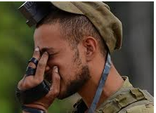

There’s a story Rabbi Yoel Gold told of a young soldier who was training for Shayetet 13, the most elite combat unit in the Israeli Defense Forces, and the world. In order to get into this unit, grueling work is required.
One of the final tests was an exhausting task of proving survival skills. Soldiers would hike 40 miles with 40 pounds on their backs, without drinking water for a full day. This boy was making his way up the ranks, and his life's dream was to get into Shayetet 13. He was religious, and the test started before dawn.
As he noticed the sun making its way up, he said to his officer, “Can we stop just for a minute, I have to put on my tefillin.”
The officer said to him, “Not now, maybe soon, just a little while longer,” and they kept going. After another hour he asked again, “Please Sir, I want to stop for one moment just to put on my tefillin.” The officer said to him, “Kid, not now, you're leading the pack, and we have to keep going.”

“…I Never Missed a Day of Tefillin in My Life…”
Again, a few hours later the young soldier said, “Please, Sir. I never missed a day of tefillin in my life, please let me stop for one minute. I can only put them on until nightfall.” The commander did not allow him to stop. Nightfall was rapidly approaching. With only a few minutes left, the soldier declared, “Mefaked (officer), I need to stop.”
The officer turned around and said, “You want to stop? You want to give up all your years of training? For tefillin? My friend, right now you have a good chance of making it into this elite unit. It’s not going to look good if you fall behind now.”
Without thinking much the boy said, “OK that’s fine. I have to stop.” The unit kept walking without him. The young soldier sat down, took out his tefillin, slowly wrapped it on his arm, and watched as soldier by soldier walked by him, watched his opportunity to become the next elite combat soldier pass him by. The boy prayed, “Shema Yisrael Hashem Elokenu Hashem Echad.”

“Welcome to Shayetet 12…”
He put his tefillin away and saw his Mefaked standing in front of him, waiting. He said, “Welcome to Shayetet 13. Congratulations.”
The soldier was at a loss, not understanding why he passed if he did not complete the test. The Mefaked responded, “Who would you want standing behind you up in the field, someone who is willing to give up everything he believes in, or someone who stays strong even under great pressure?”
Right now, our community is going through a very difficult challenge. The governor is demanding our schools be shut, and our learning cease. It is important to remember to stand up for Torah, to continue learning and educating our children, even at home. Teaching children Torah is our legacy, and we must take a chapter from Avraham Avinu’s book and have immense faith in Hashem and stand up for Torah!

Reprinted from the Parshat Lech Lecha 5781email of Jack E. Rahmey as based on the Torah teachings of Rabbi Amram Sananes.

